University of Bahrain

Kingdom of Bahrain

College of Information Technology

ITIS243 – web design

Report about DNA company web site

Done by:

Jenan merza:20181922

Maraya Ejaz ahmed:202004634

Fatima alhadi:20191810

Abdulwahab Hamed:202004389

Amina salah salem:20197485 sec2

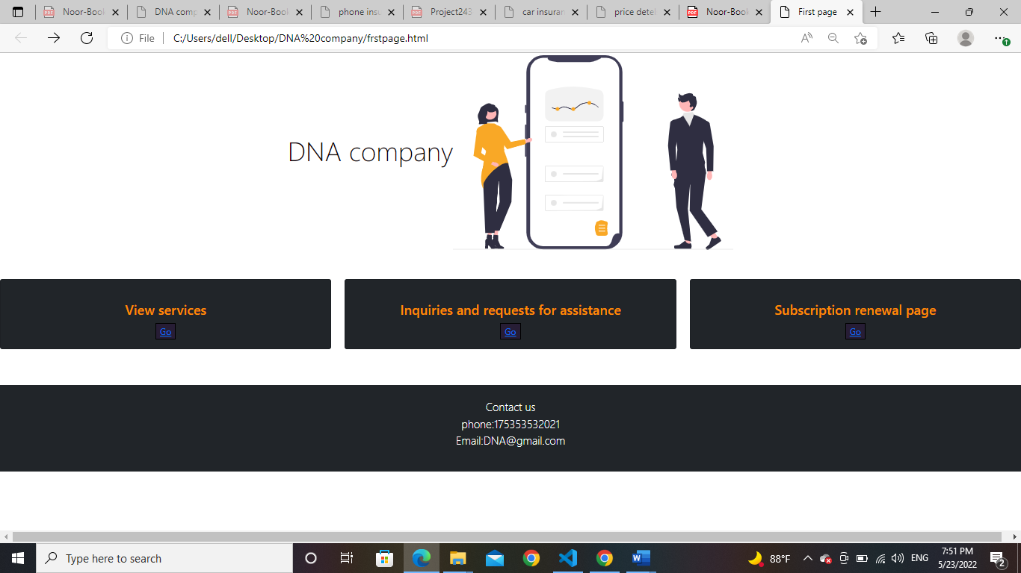

This was the first page of the site, and the page was divided into three sections. The first section contained the company's name and a picture, the second section contained three basic services, and the third section contained the company's contact information.

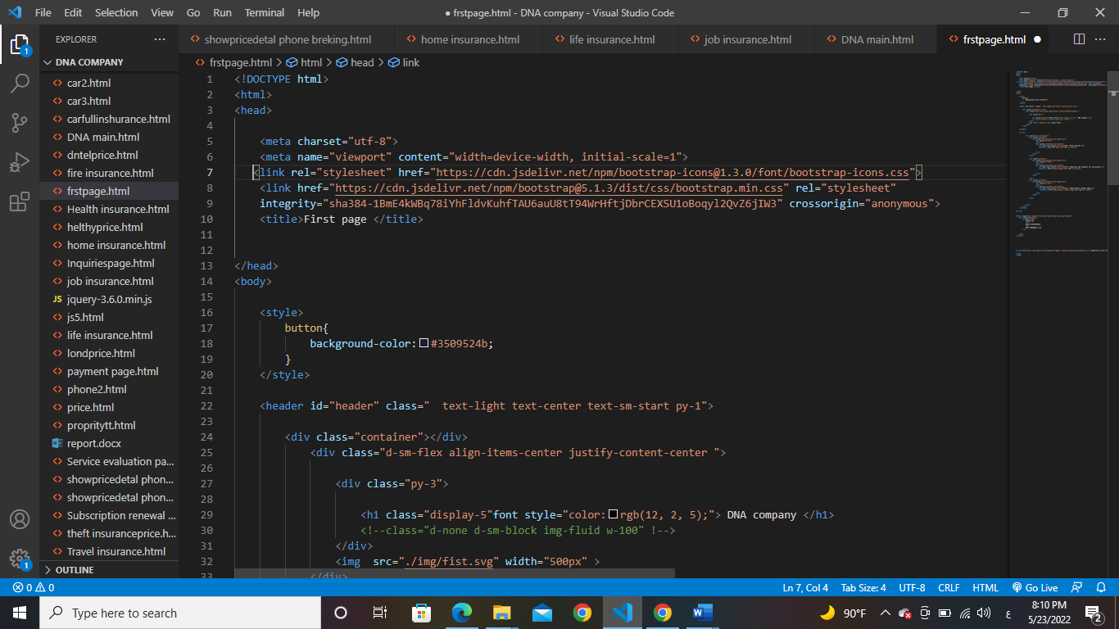

This was the code we use it to make the design for the first page and in the Initially we used bootstrap frames to format the page so that a page can be configured on each device frame with a different screen size and we used images on all pages from m <https://undraw.com> and we use the title tag to rename the page to first page and we put whole this code in head tag.

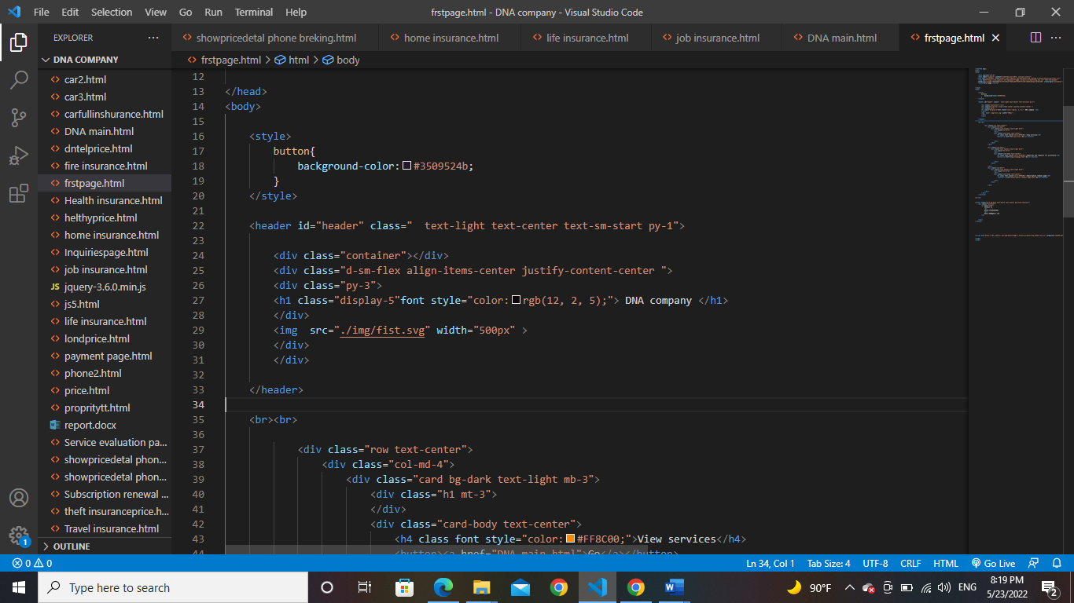

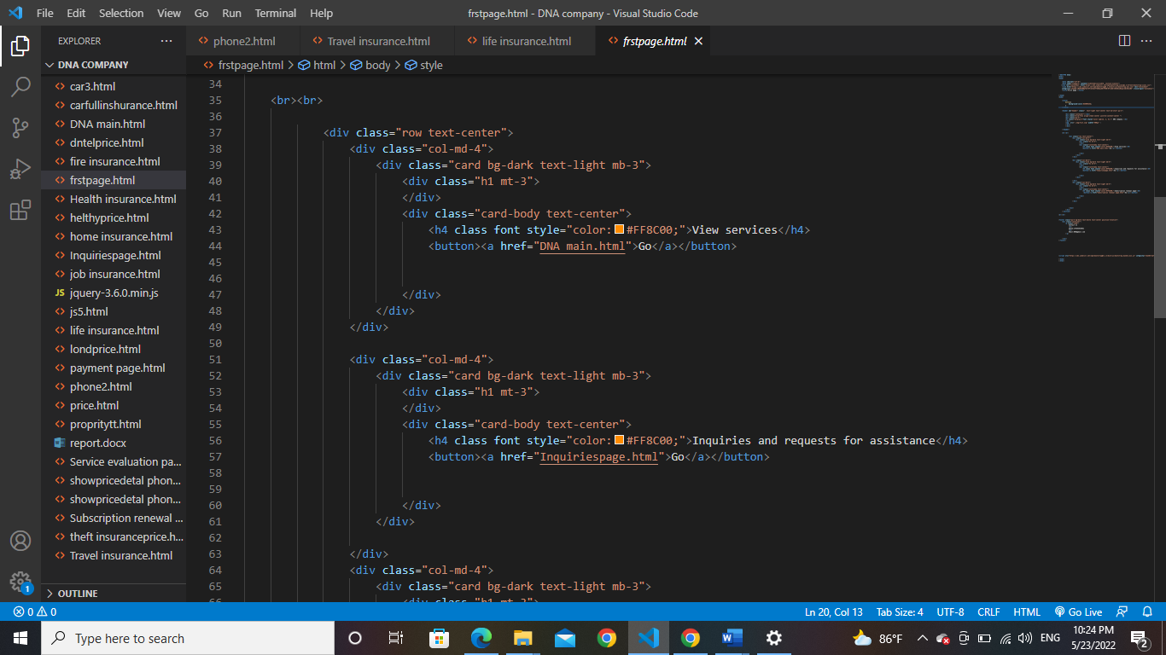Then in the body tag, we used the header tag with a coordination of the bootstrap. We used a ready-made class that adds a light-colored section to us. Then we used the Class Counter division. The page is divided and we gave it the ability to shape according to the screen size and we gave the class a property -3 to be divided into 3 to the image and -5 to the title and from Then we gave the title a color and we determined the characteristics of the color and we determined the type and size of the image.

Then we also used the division of the post strap to divide three main sections, so we used the counter feature in the bootstrap to divide the page section into three sections, each the section having 4 columns on the page. Then they used a button with a link to the other page inside.



And we repeated the same code to divide these sections, as these sections were divided using a bootstrap counter, for each section 4 columns.

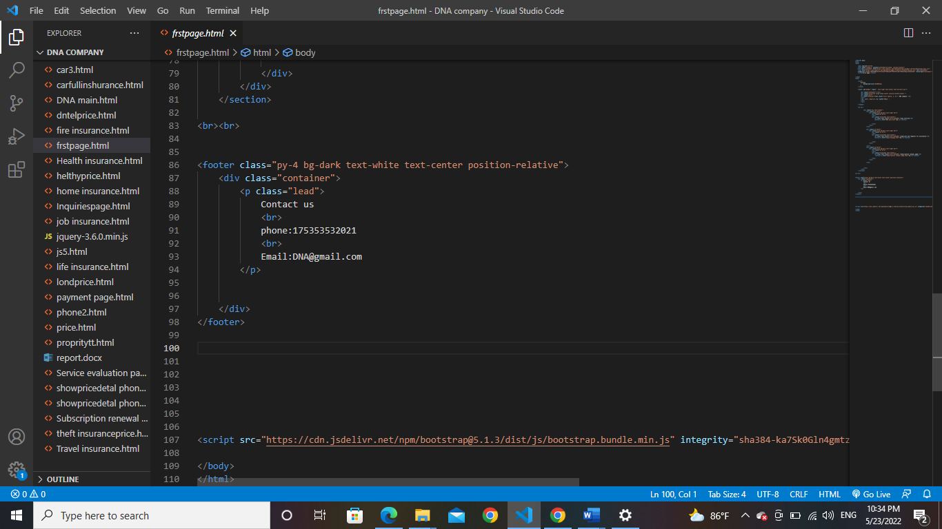This was the last part of the first

And we used this code to create this section, where we used the footer tag, and then inside the tag we used the bootstrap counter-4 division to make all the page coordinate with each other



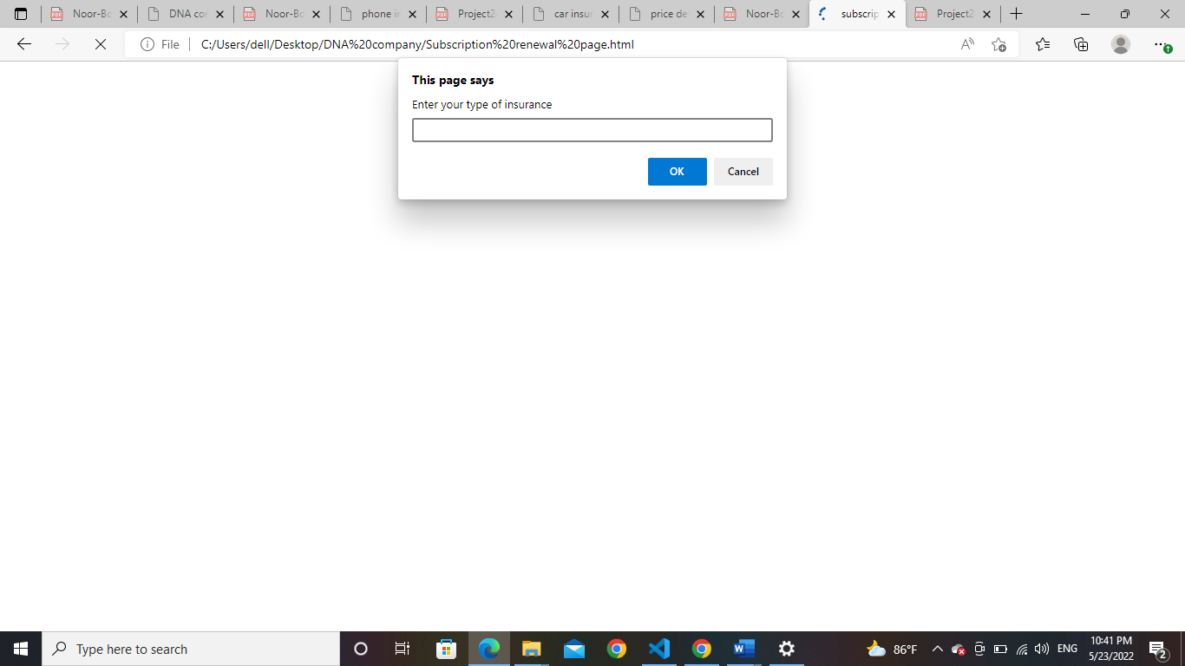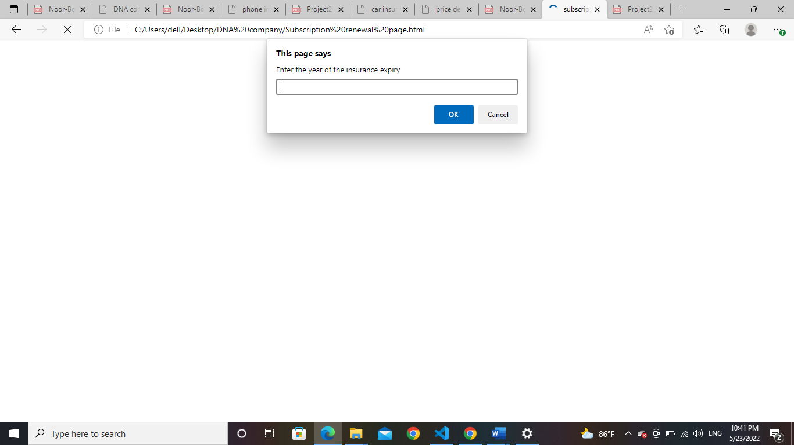 The first section was the subscription renewal section the first section was the subscription renewal section, and the hyperlink was taken to the page to fill in the information

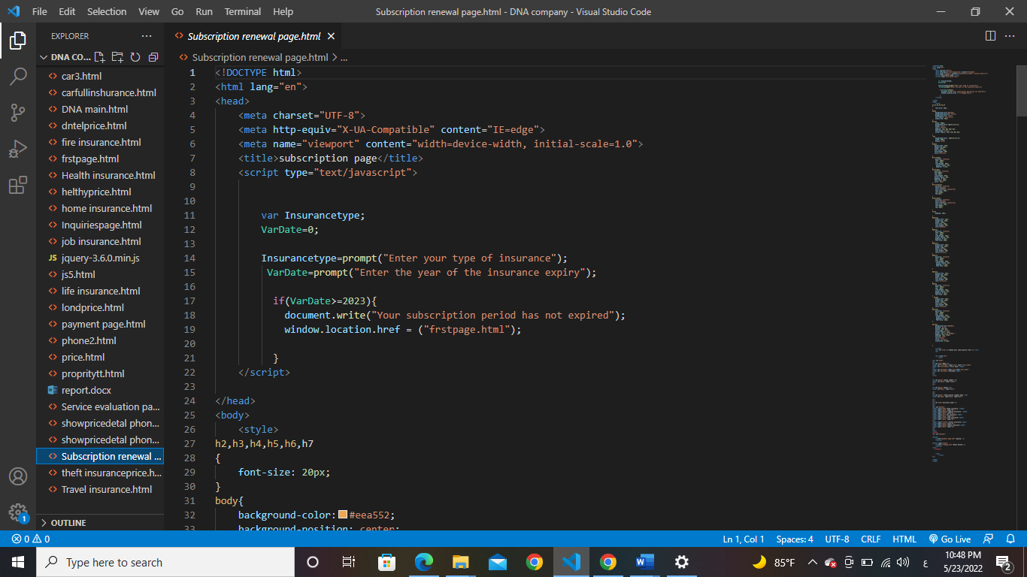The first section of the page asks the user to enter the type of insurance and the year of expiry, and the user must enter a year less than 2023. If he enters a higher year, the site will exit the user from the page and we use this code JavaScript for this page

In the beginning, we put the JavaScript tag under the head tag before tagging the body and we used the printing method from the window to appear to the user when he opens the page and we asked the user to enter two information, the name of the insurance and the expiry date, and using the if statement, and our condition is fulfilled, provided that the expiry year is less than 2023 in case of agreement Condition The user will move to the payment form, and in the event of a breach of the condition, the user will exit the page and return to the main page by including a link to the two pages and the condition 2023 <=.

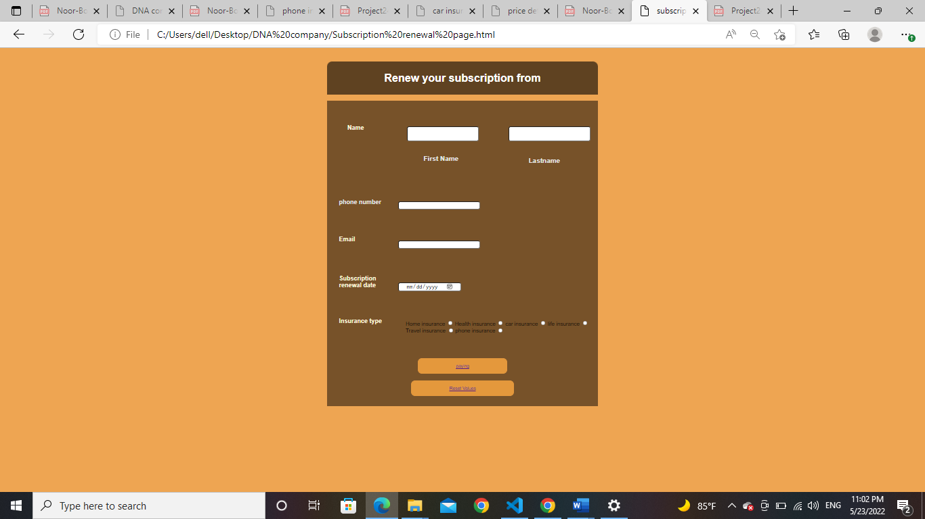

This was the page that contains the payment form that the user will go to if he agrees to the terms and we used the following codes for this page.

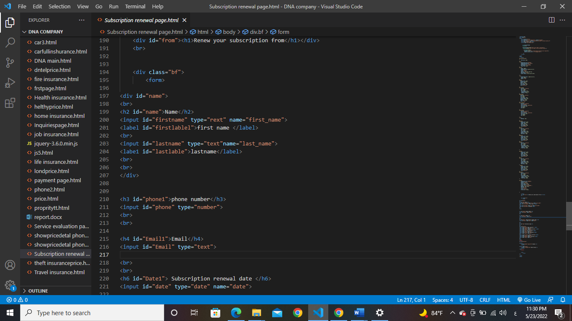

At first we used tag from to add the payment form, then we used tag h2 to add a title to the form, then we used tag input to be able to enter a text box through which the user can enter his information, then we used tag Apple to name each type of text box with a name and we divided the first part that contains the name The first and the second name using a tag div to be able to change their places or give them distinctive characteristics later and the types differed between each label due to the difference in the information entered between the number, text and date.

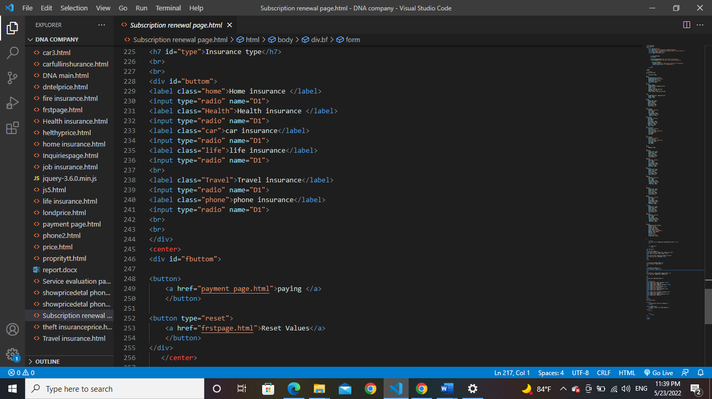

To select the type of insurance you want to renew the subscription to, we chose the radio button using Tag input and gave it the type of radio button We named all the buttons with the same name so that the user is not allowed to choose more than one type In the end, we added a button using the Tag button, one of them takes the user to the payment page and the other deletes his information and we put them in the middle of the form using the Tag Center.

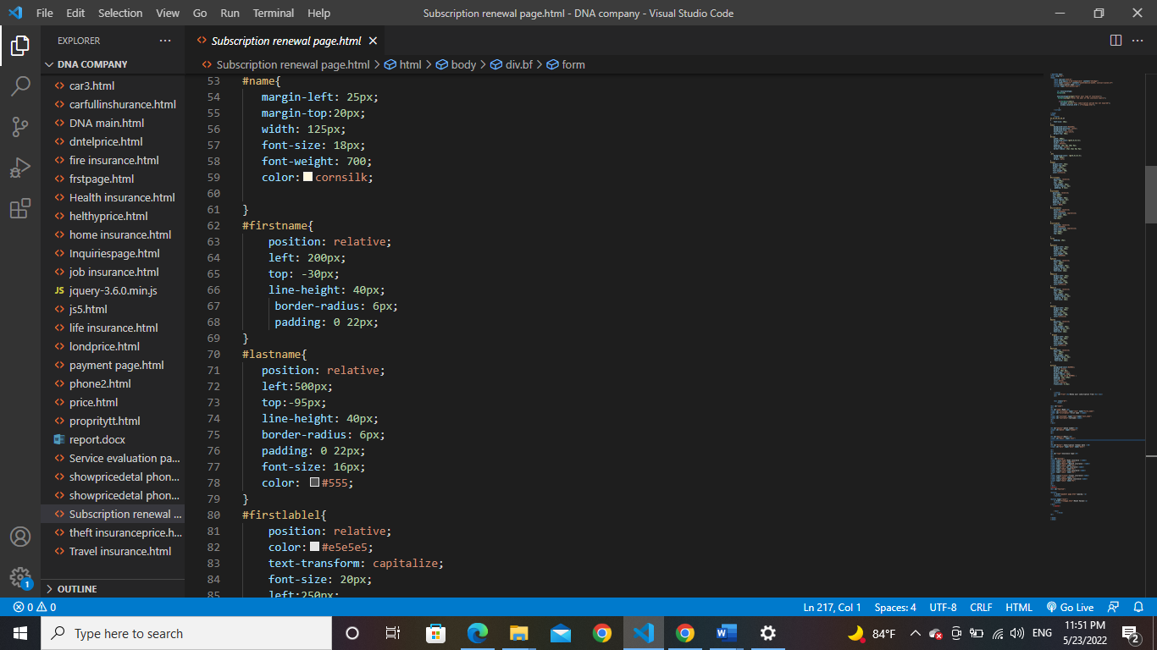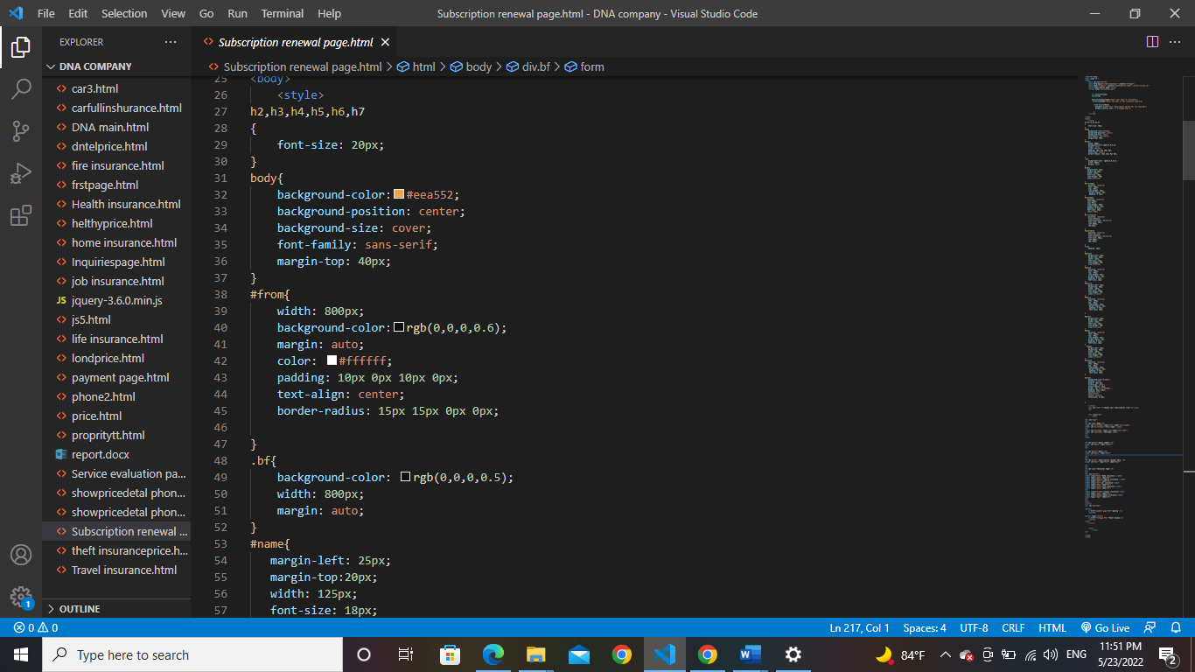

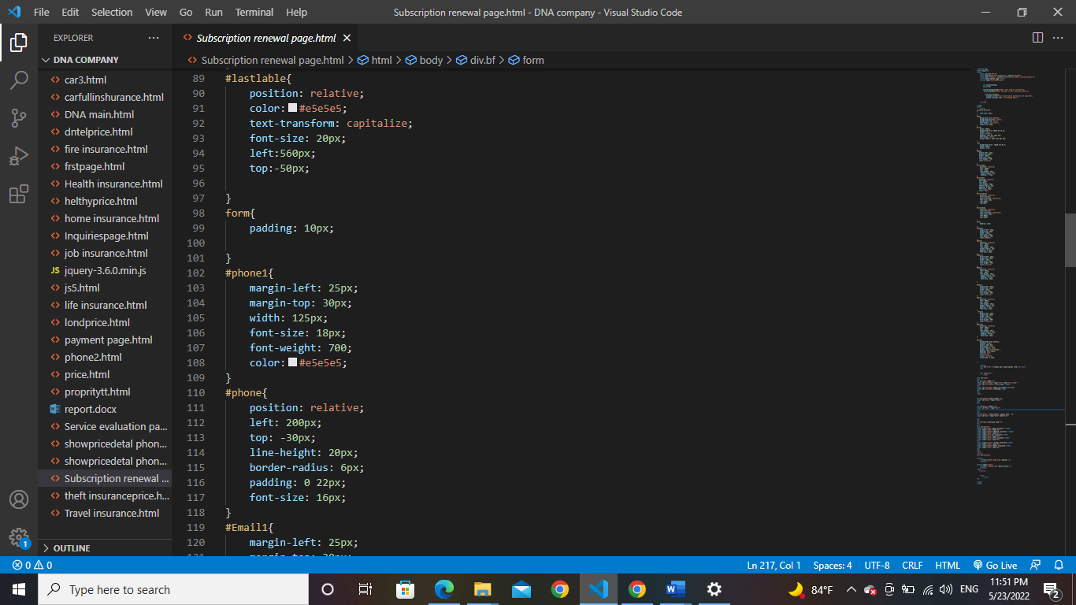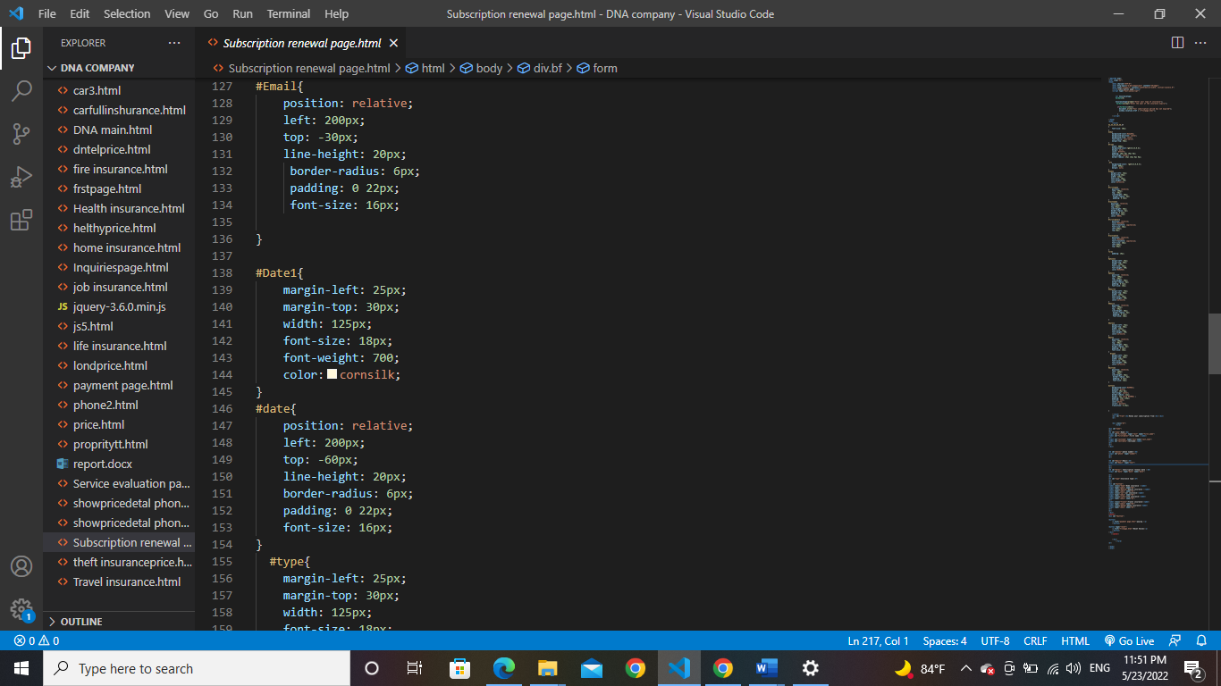

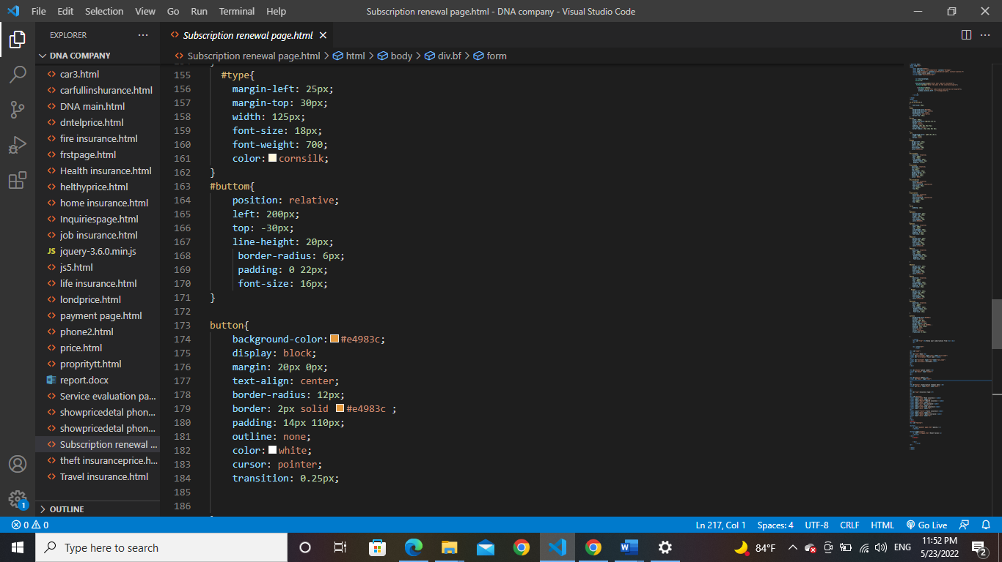

To color the page and create designs, we added CSS instructions under the tag style and used the identifier that we gave to each section before to add colors and modify places and the way to use was as follows. If we define the show using id we must use # and then the name of the element to add whatever we want then write any property we want to add to this element, then: the type of the property, for example color: red.

After the user has completed entering the subscription renewal information, he must go to the payment page

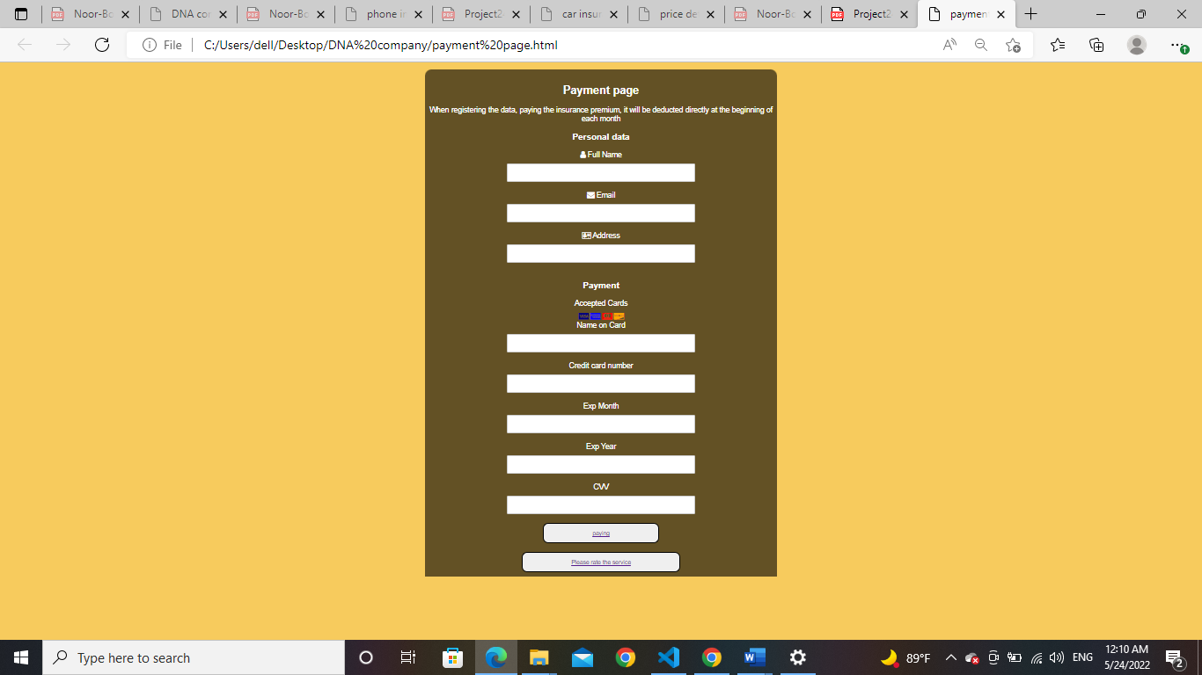

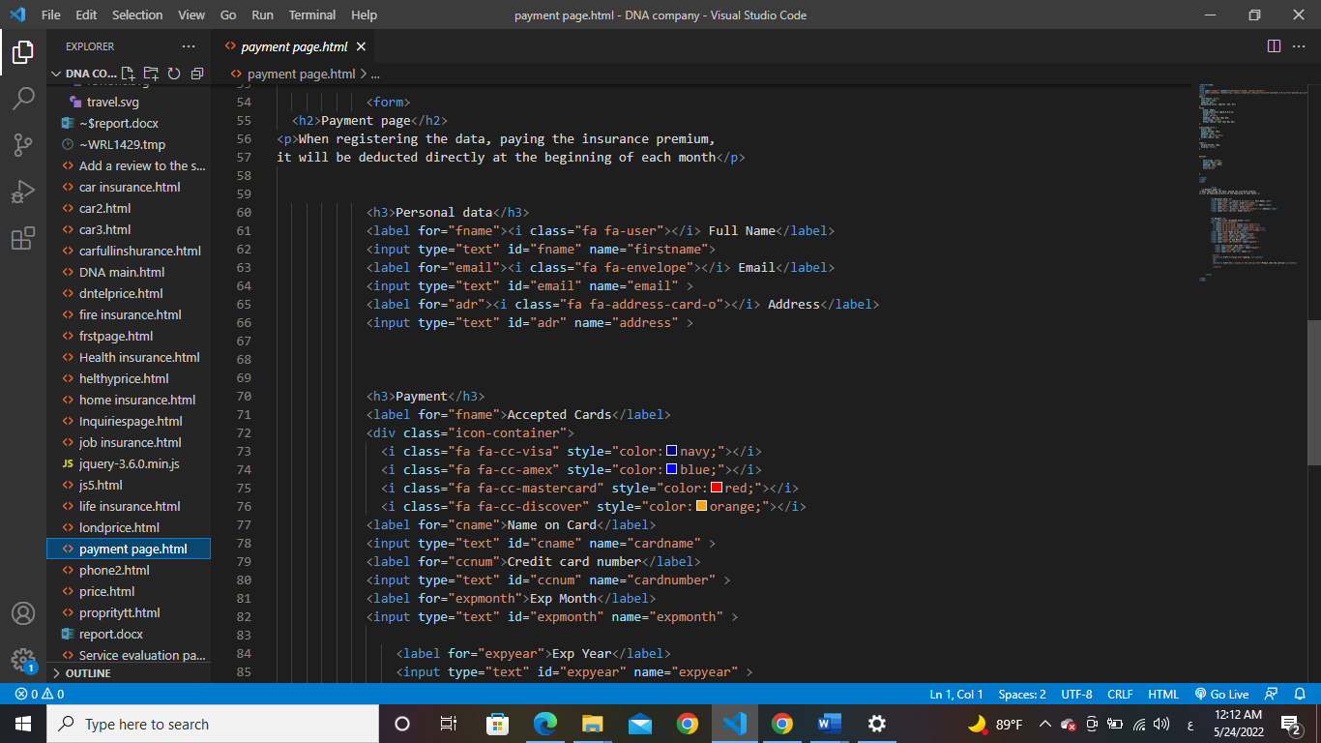

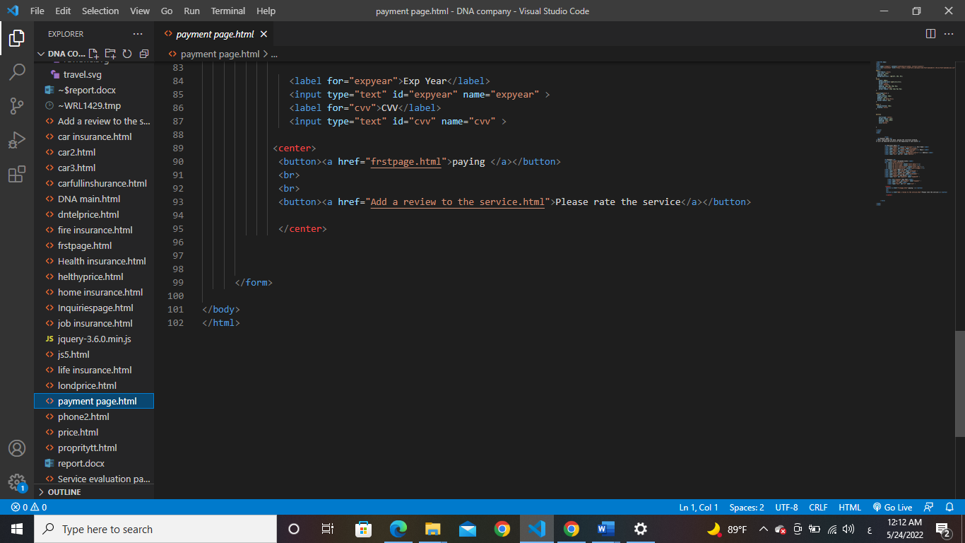

The codes we used on the subscription renewal page are not different from the codes used on the payment page, where we used the label and the input tag in the same way, but on this page we used forms of bootstrap such as the envelope symbol and the email symbol and we used these codes by adding and inserting them inside it We also used the CSS language in the same lines by adding the style =" " and writing the property we want between the quotation marks and also we used the i tag to add a list where we added the images of the cards allowed to be used.

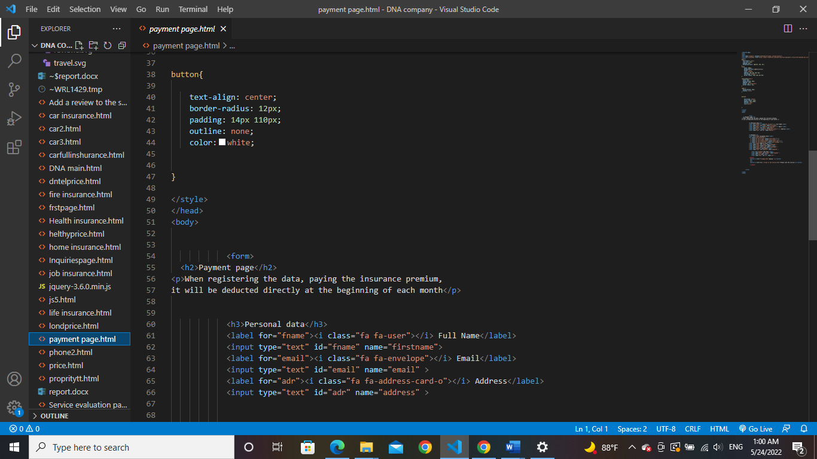

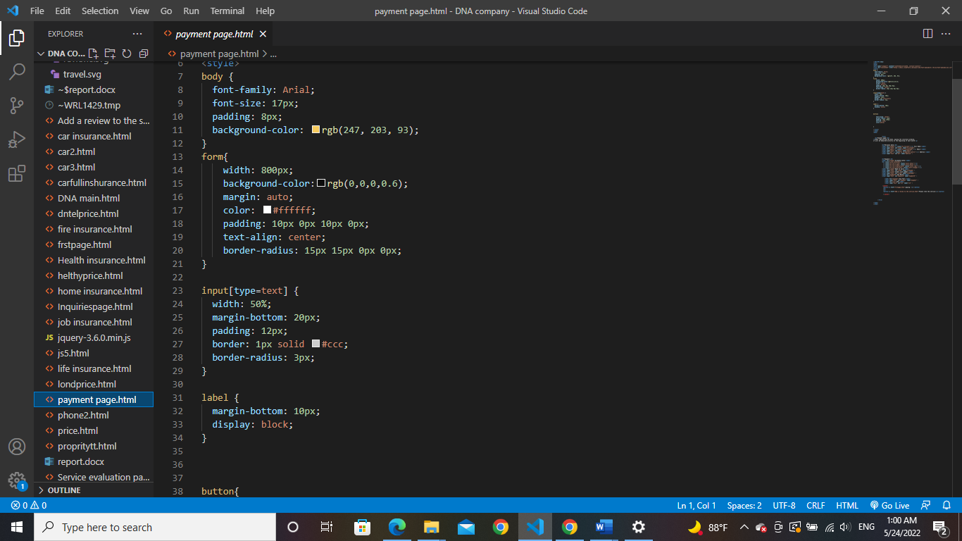   
These are the CSS instructions we used to format this page.



This section of the first page was taking the user to the next page

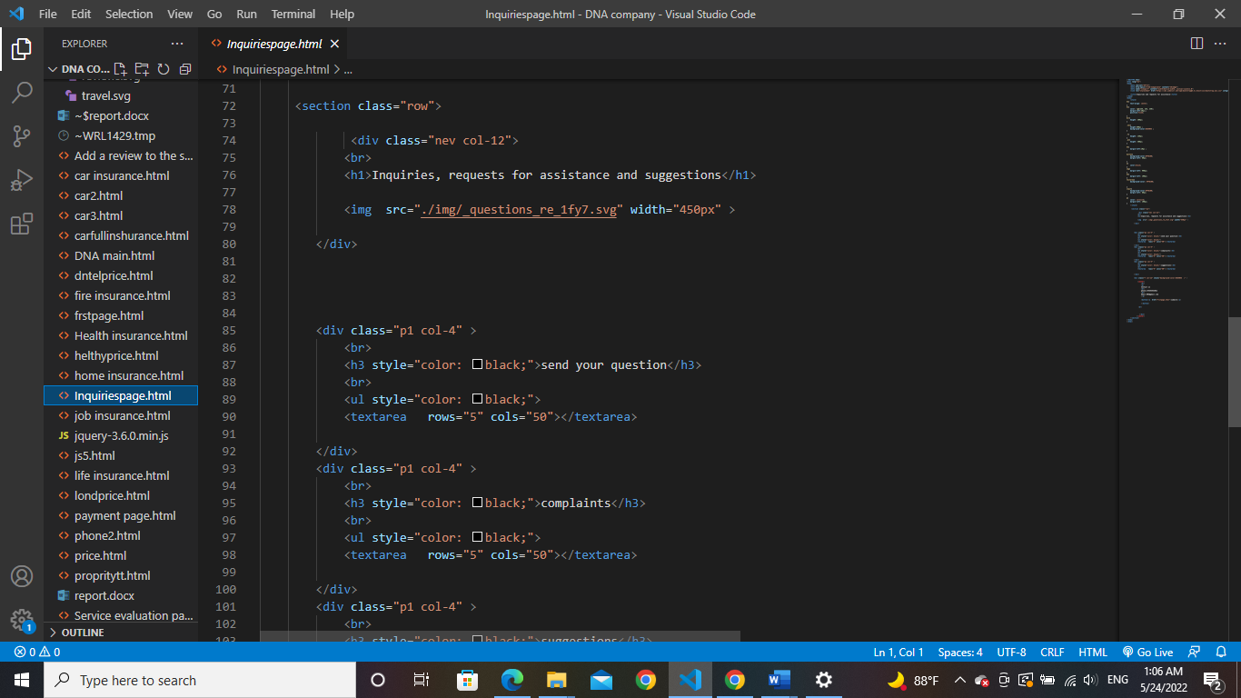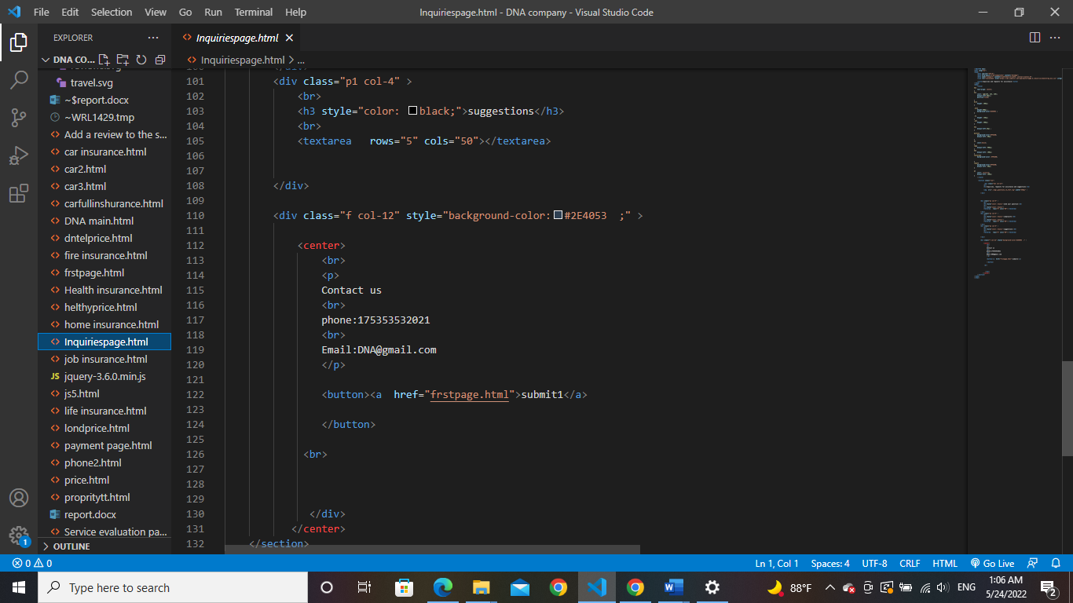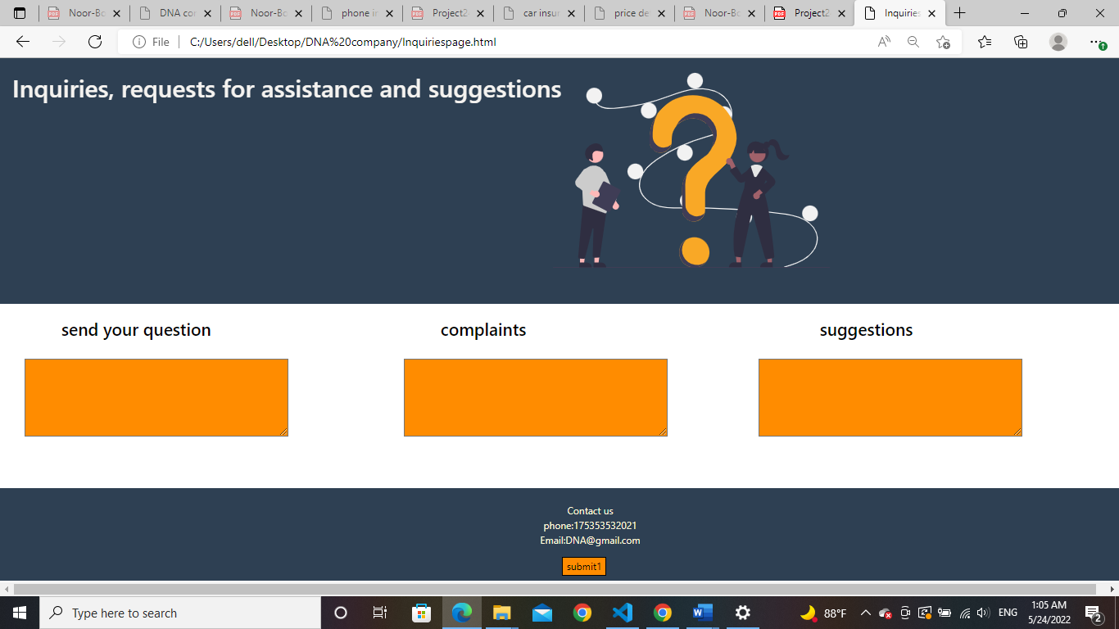

We used the same bootstrap template and took the image from the same site and the addition was in dividing the bootstrap counter into 4-4-4 with the addition of writing text on each page and a submit button at the end of the page using the tag button and we added a link inside it

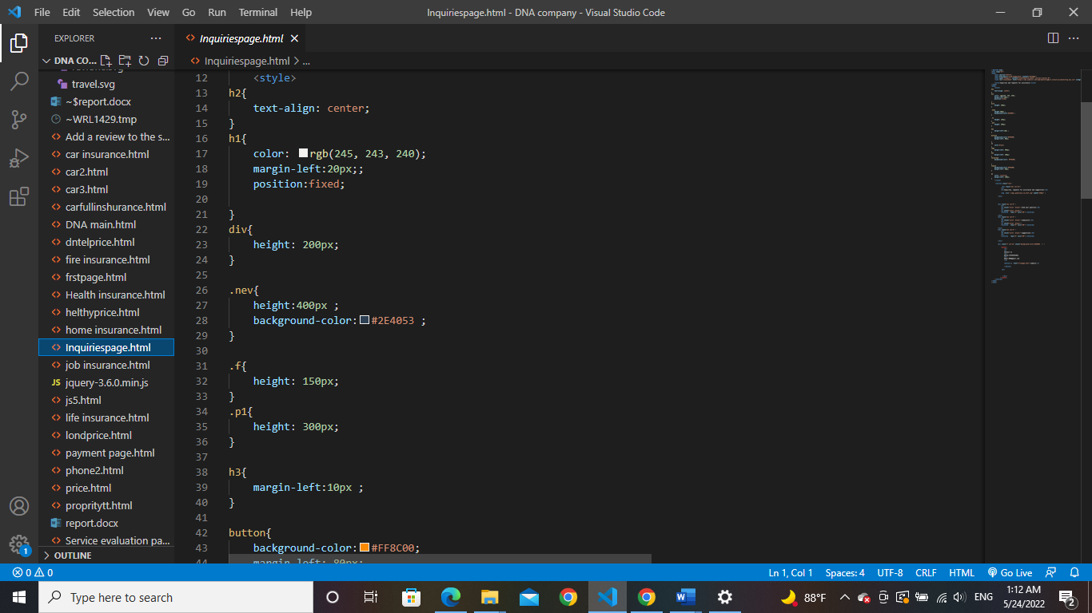

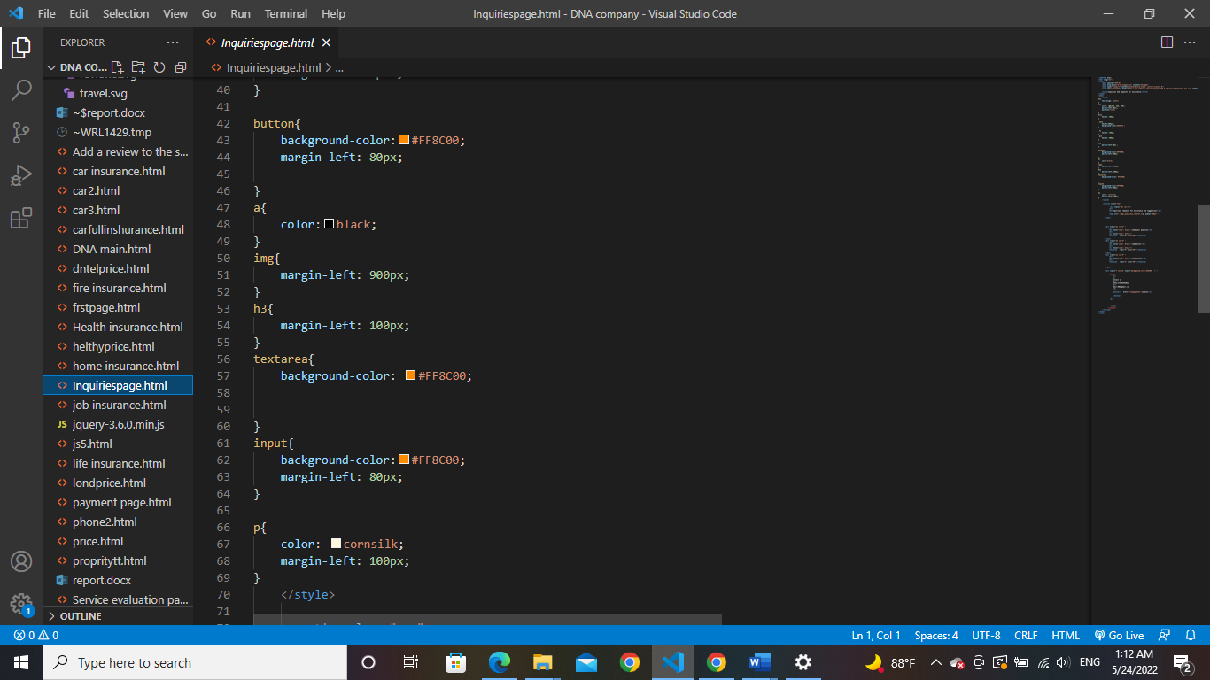

These are the CSS codes we used to format the page



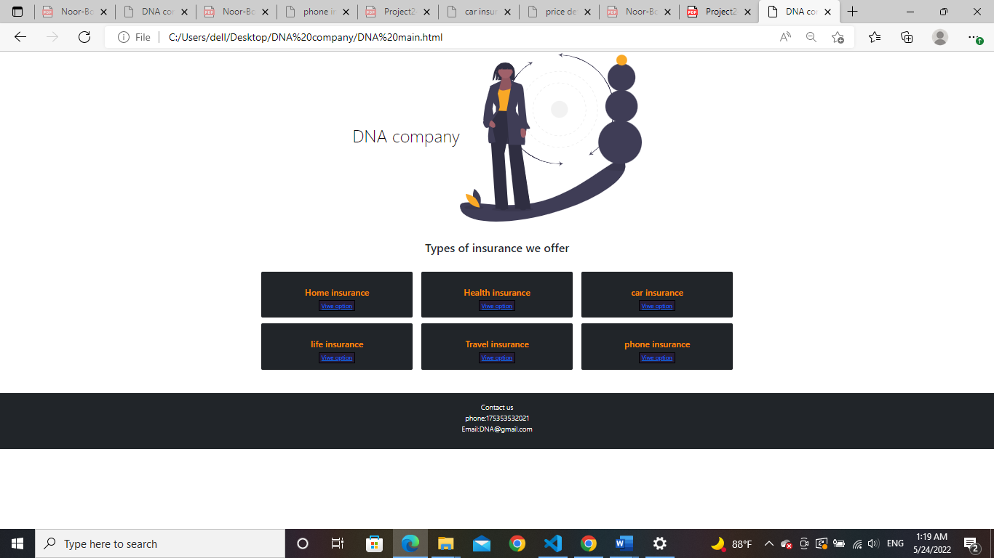The third section on the page took us to this page

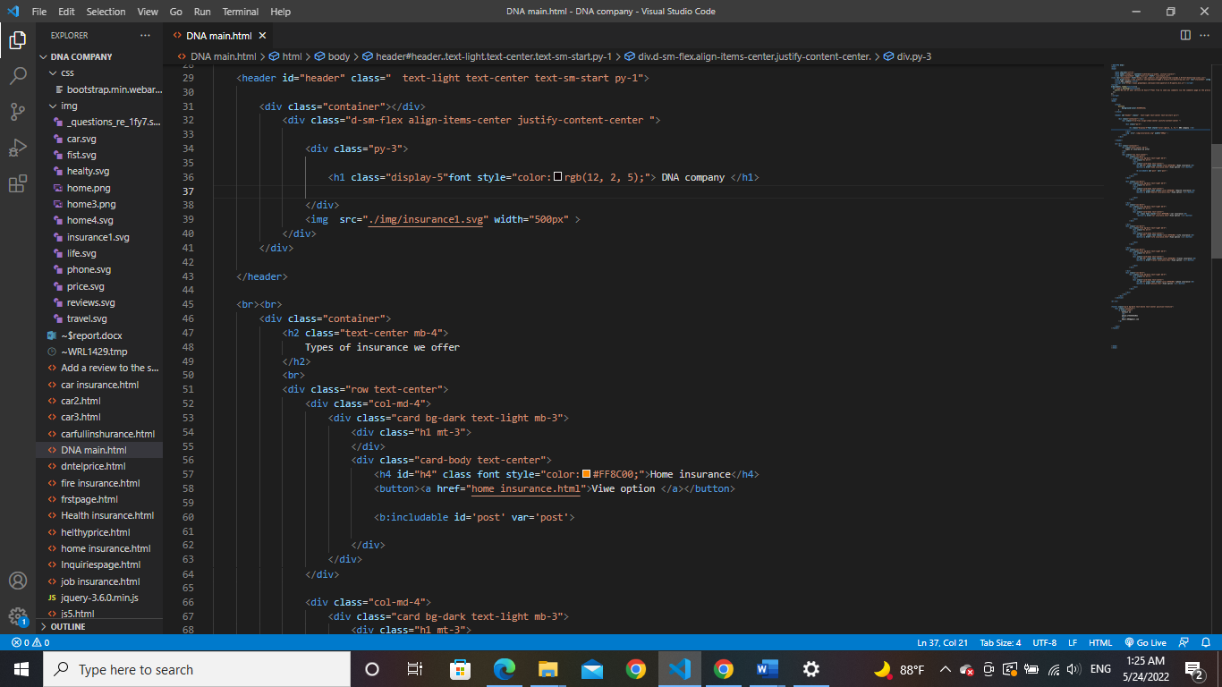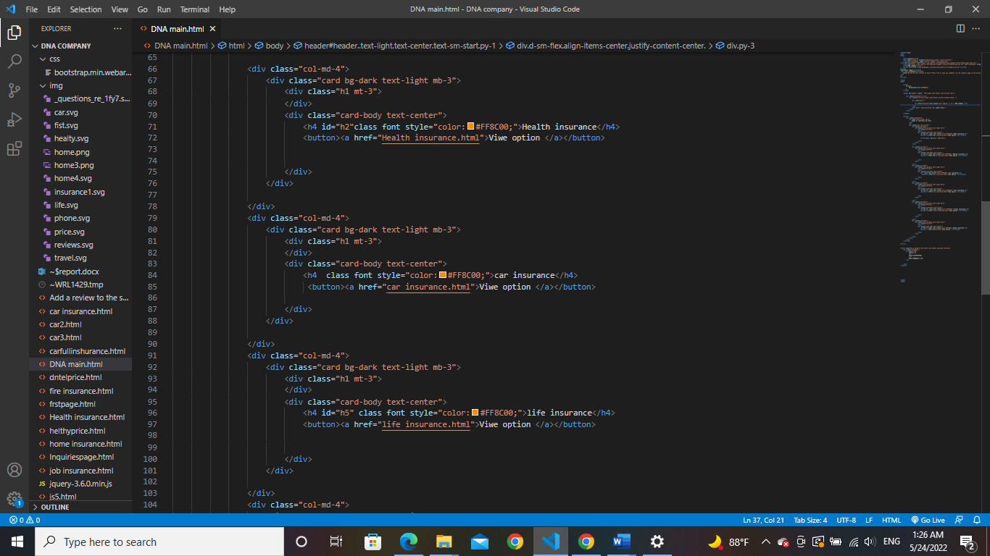We used these codes on this page

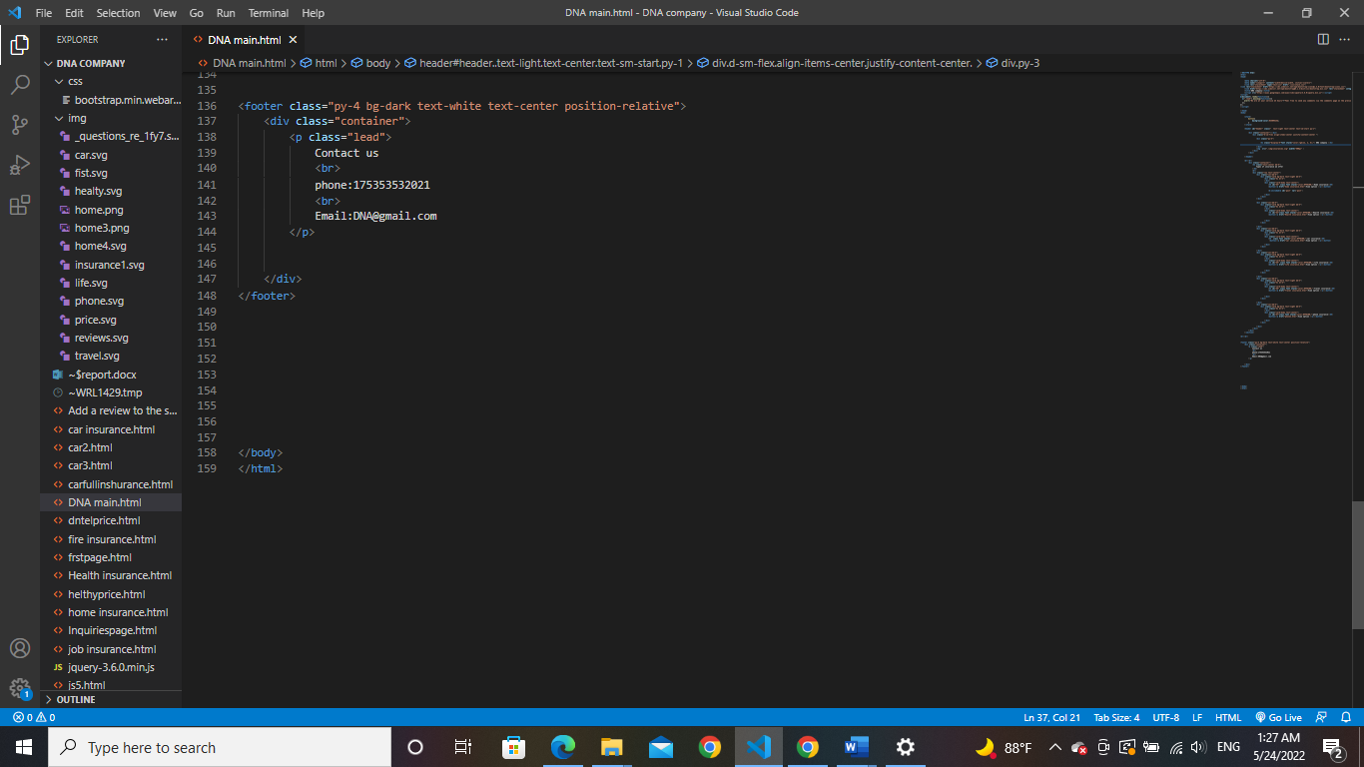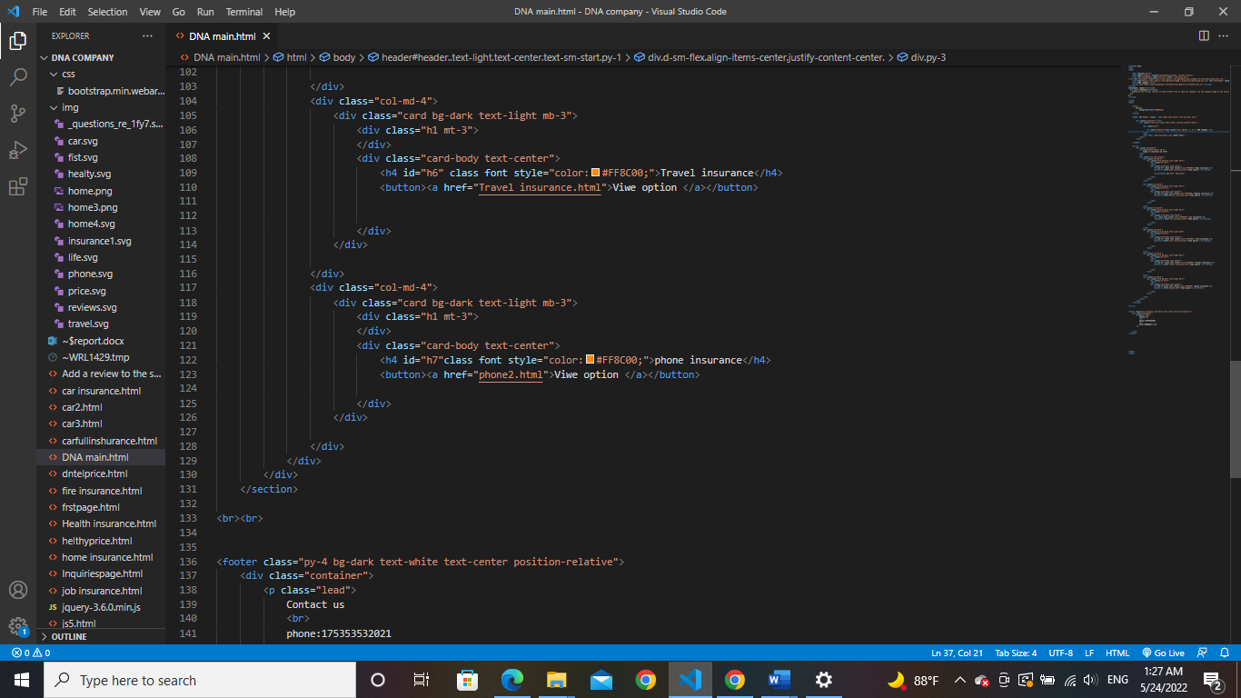

On this page, we used the same bootstrap division used on the previous page, but we added more sections using bootstrap Counter -3-3 where each section has 3 columns and to make the page organized and footer was counter not divided to take the flexible section that is formed according to the size of the screen

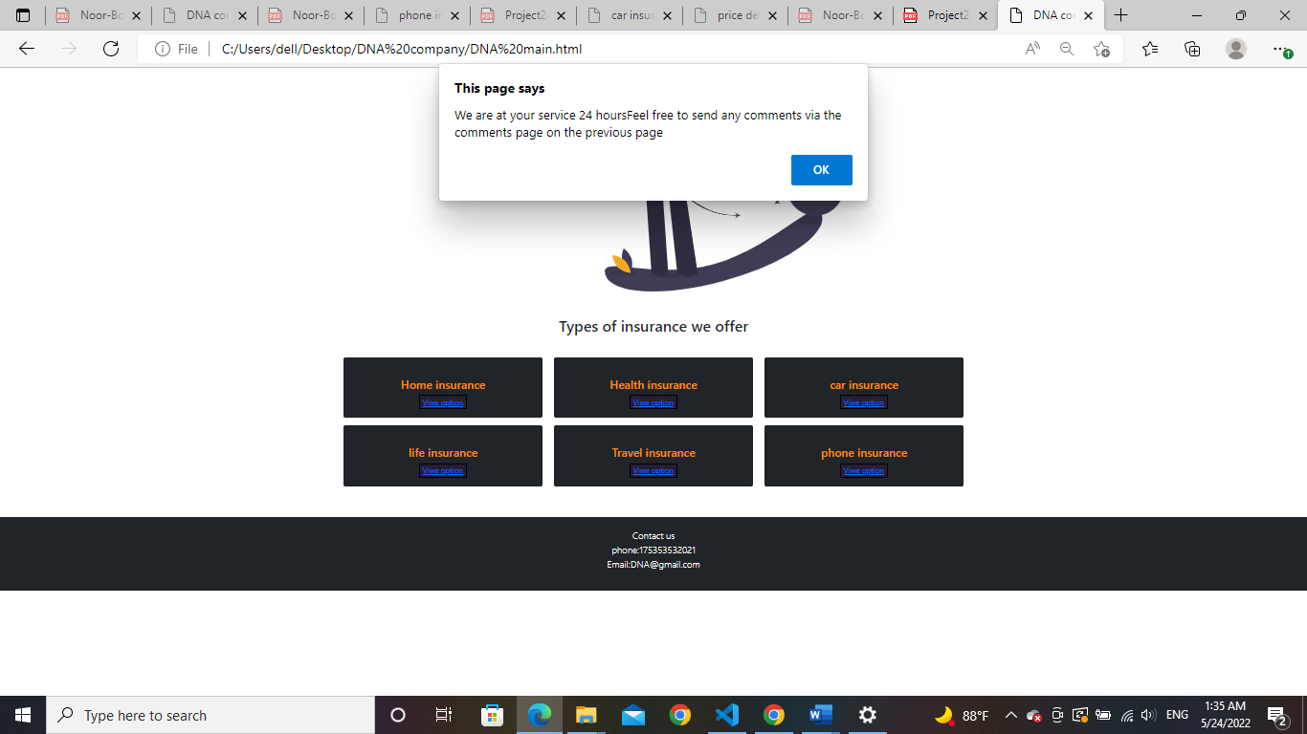

As soon as the user places his mouse around the biller, he will get this alert at the header of the page that states information and how long they can contact us for and We used jQuery instructions for this alert to appear.

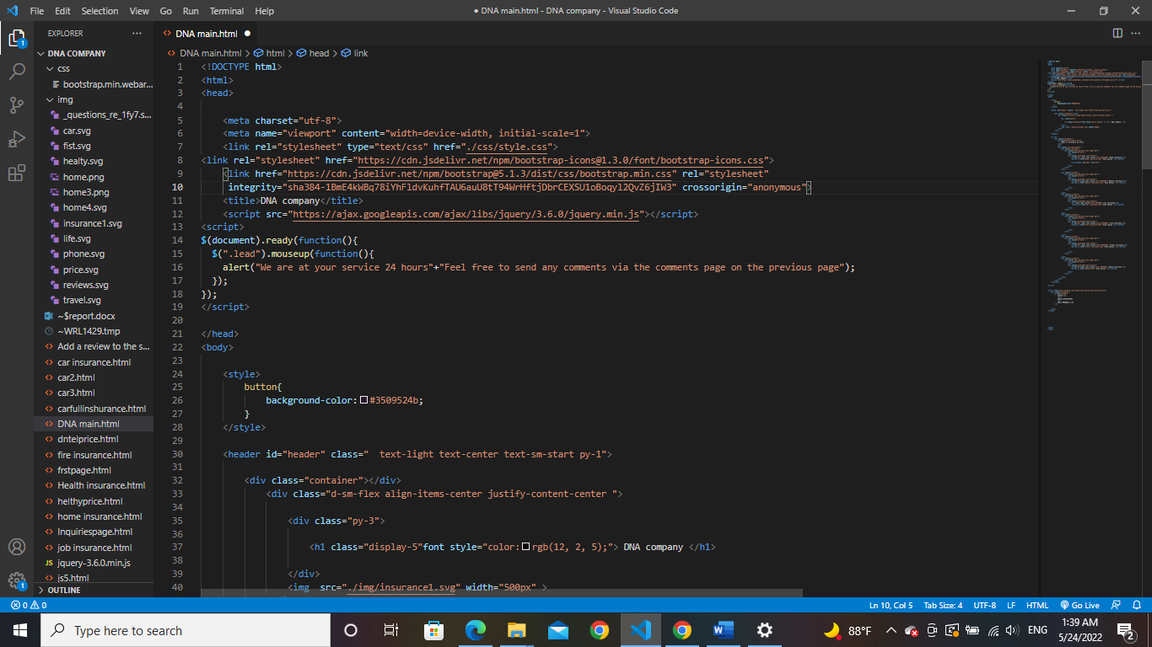

In the beginning, we added the link to the JavaScript library in the header of the page, then we used two operations that allow reading and the other process in the event that what we knew in the previous process was read through the class that appears to the user the window with the words we want.



When the user chooses any type of insurance, I will take the link for several pages. The first page contains information about the type of insurance. The second page is a page for displaying premium details, the third page is the payment page, the last page is the product evaluation page, and the last page is the services evaluation page. What differs within the pages is the difference in the process of calculating the premium and the written information about each type of insurance.

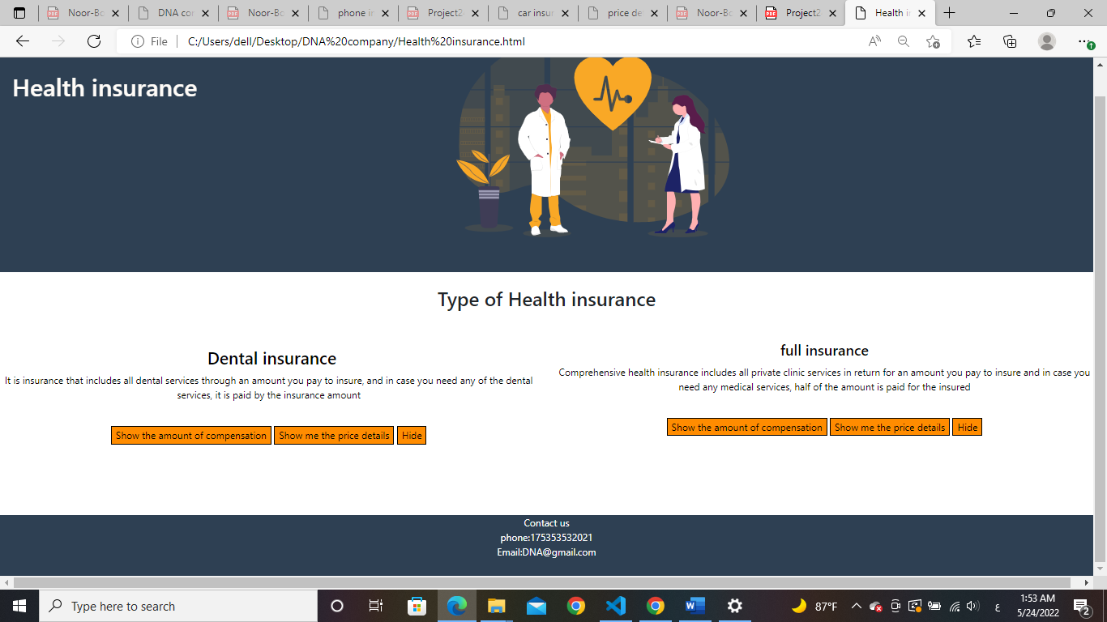For example, if the user chooses the health insurance option the link will take the user to this page

Also on this page we used the Bootstrap divisions and gave each section -6splits and formats that we explained before and we used the beginning we used jQuery code in the same way on the previous page so that the user can find the service rating if the mouse is around the first address.

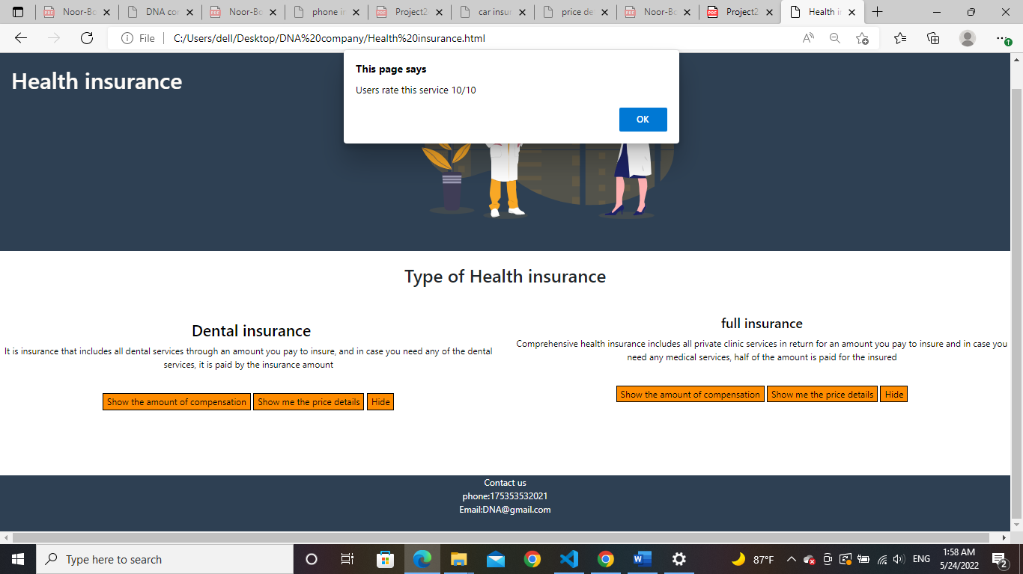

Then we also used the Korean J code so that the user could see the amount of compensation in the event that he clicked the button Show me the amount of the insurance and he can hide it by pressing the hide button.

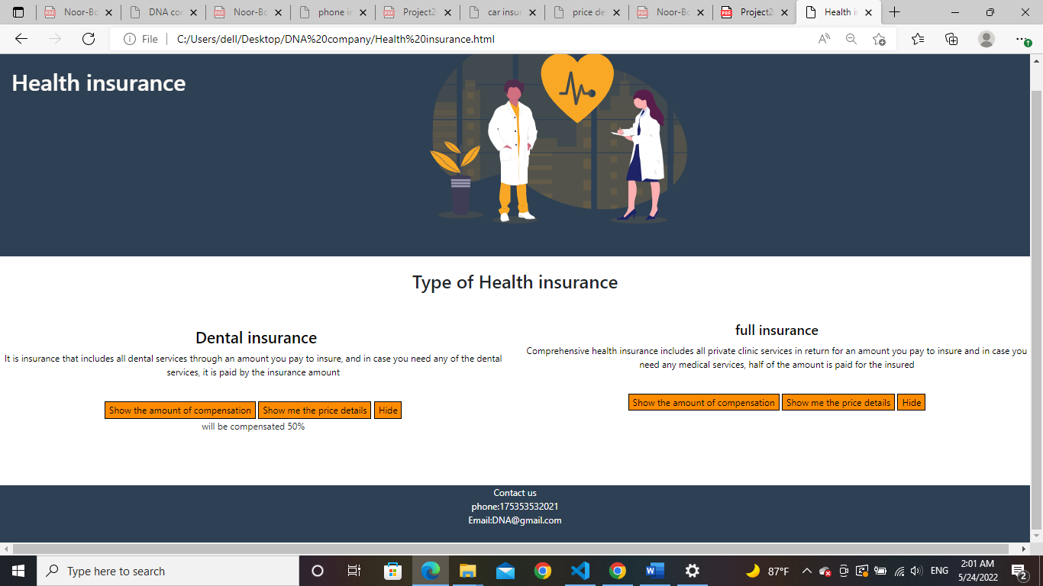

These are the codes we used on this page

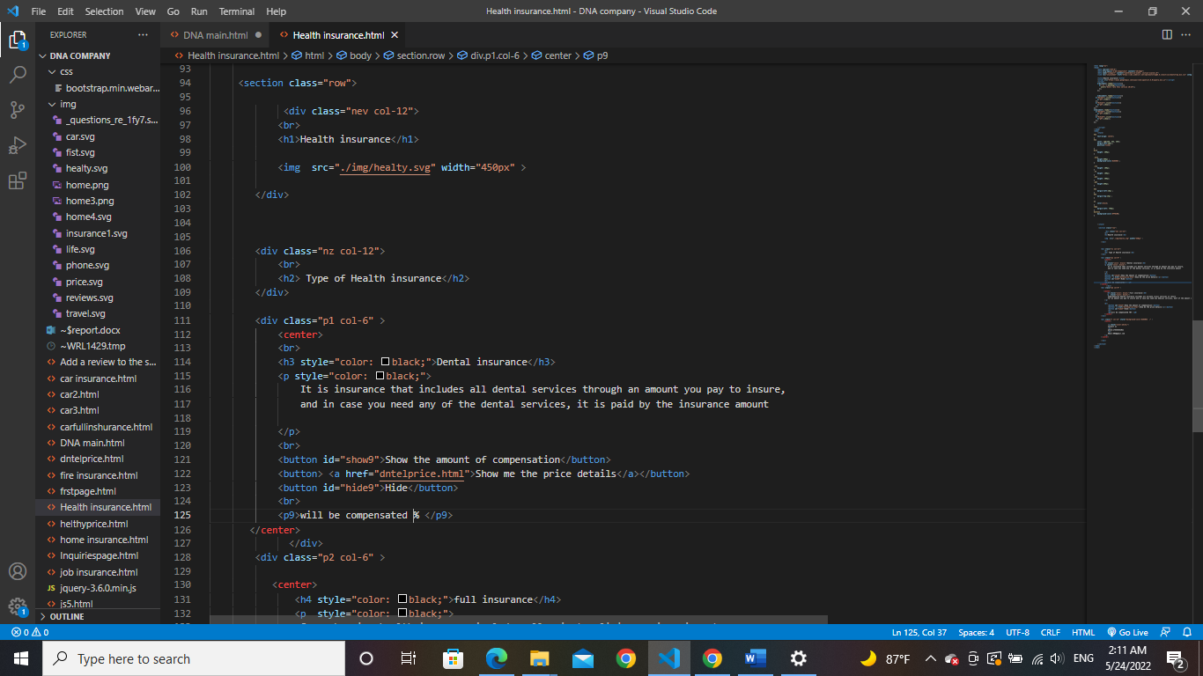

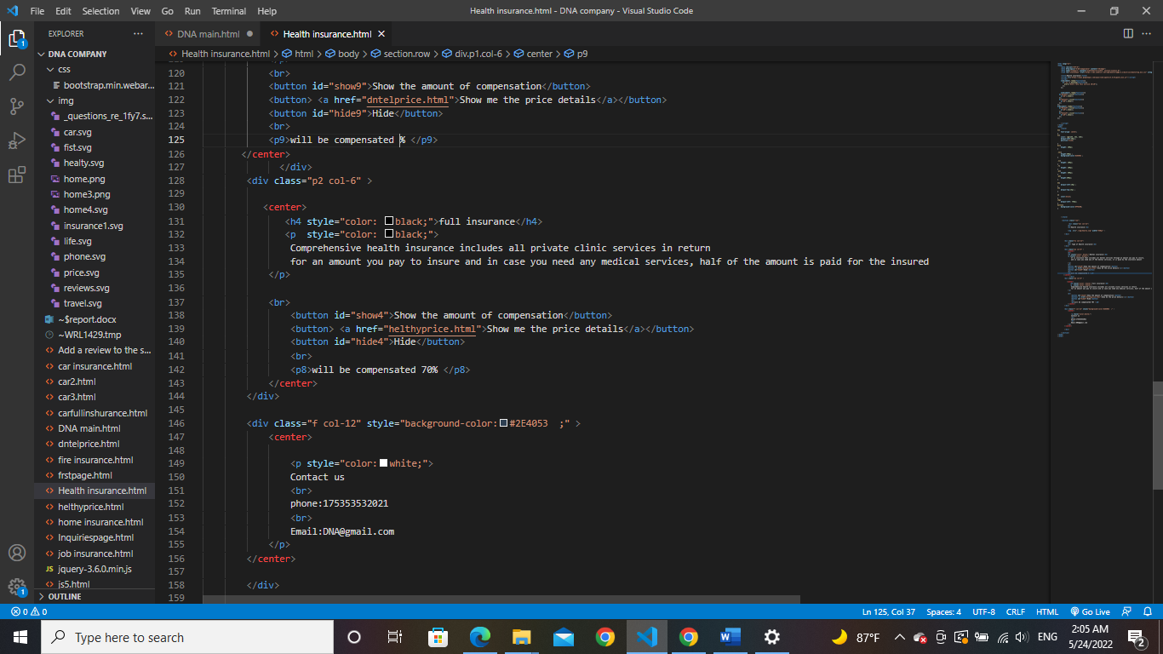

These are the CSS codes that were used to format the page

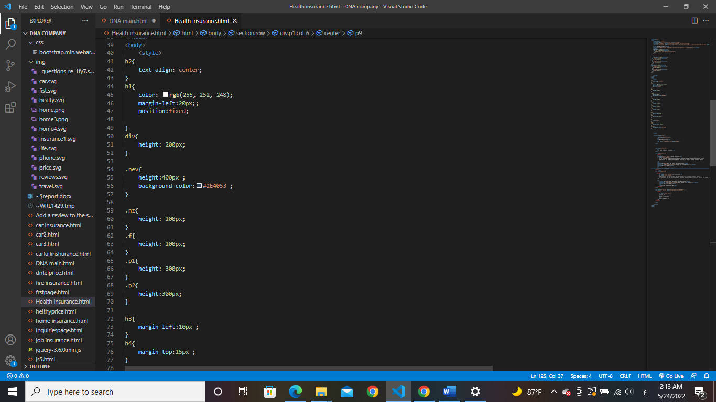

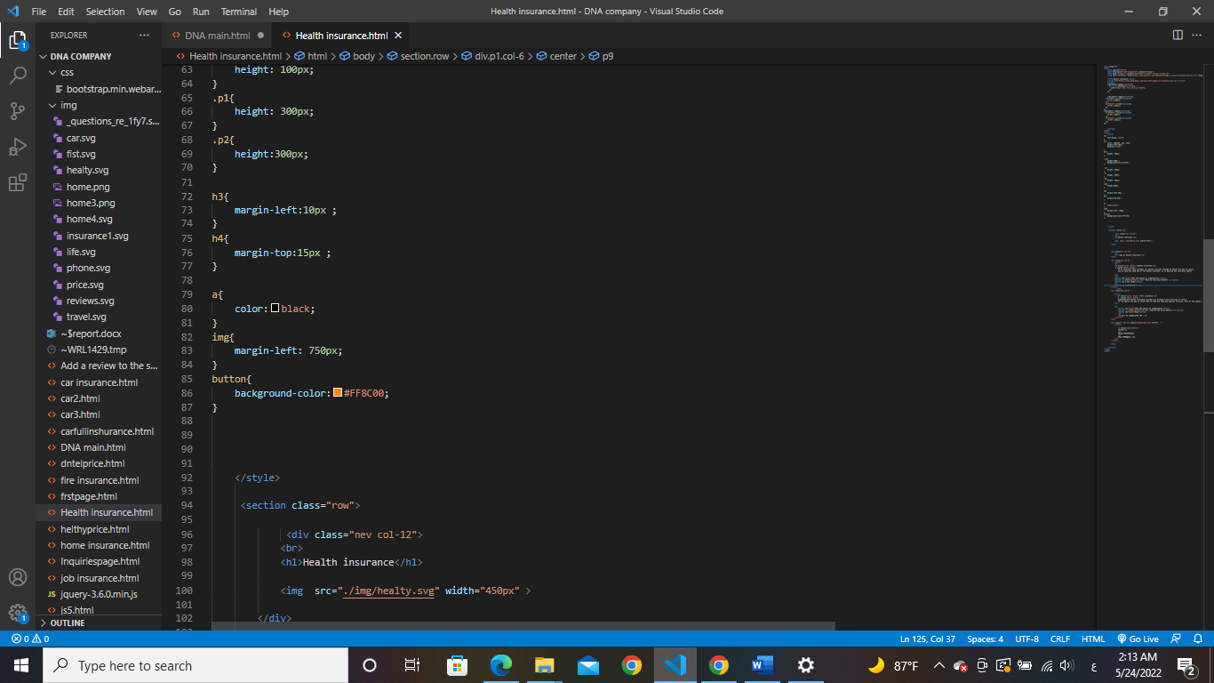

These are the jQuery codes used

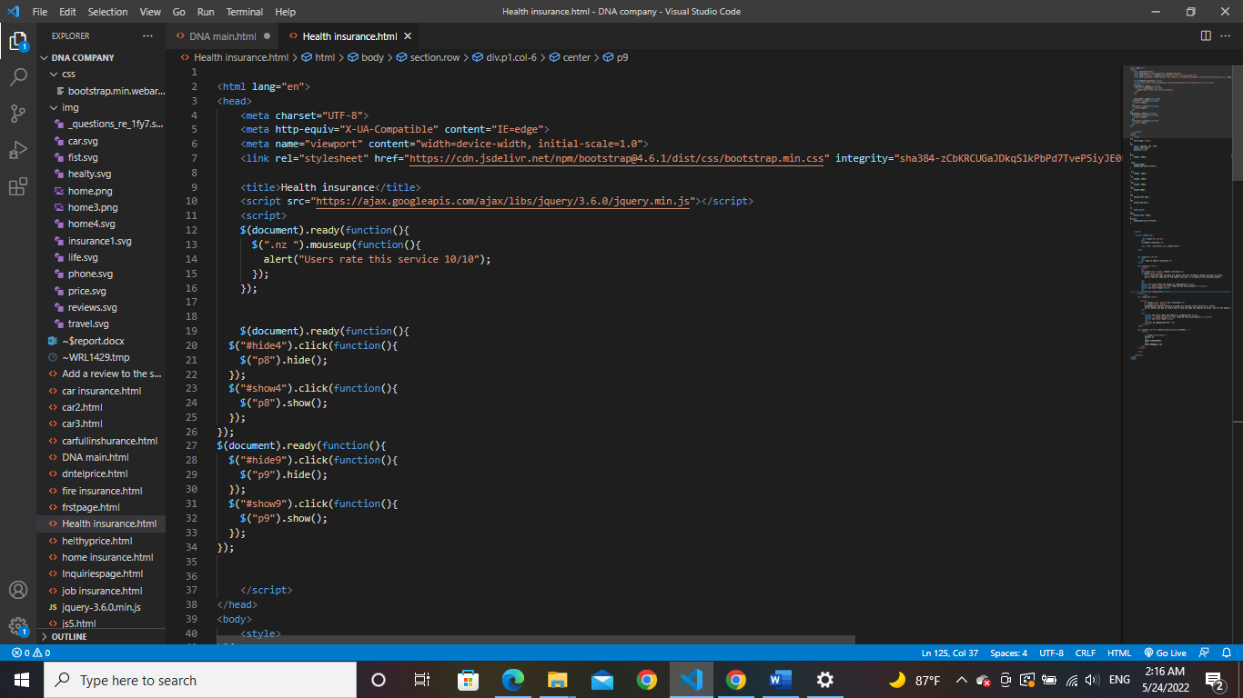

When the user clicks on the Show me price details button, the link will take him to this page.

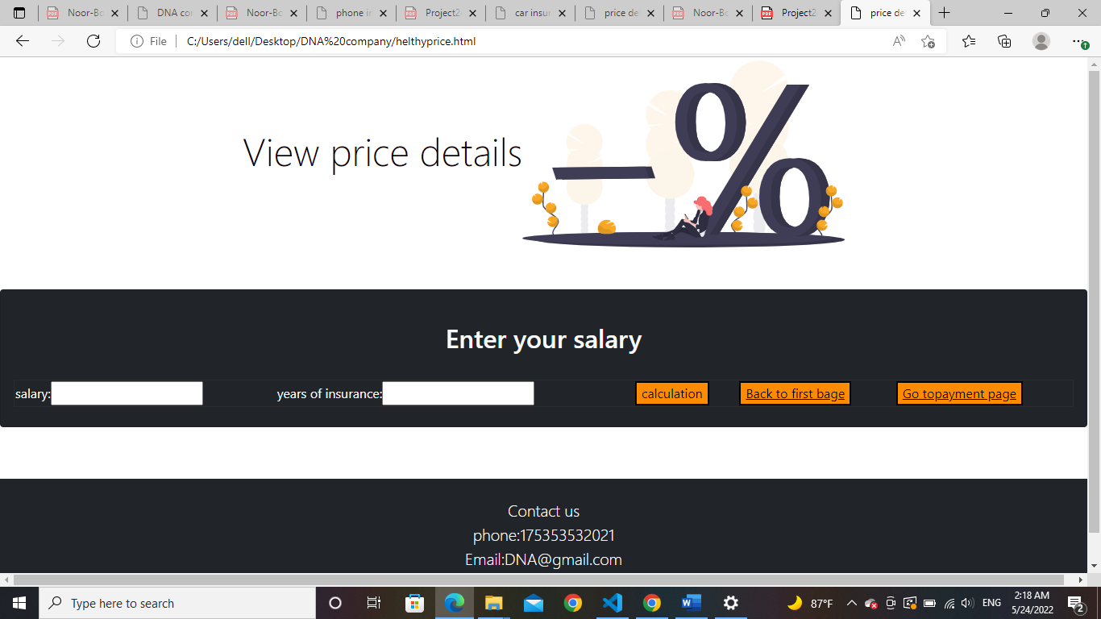

Through this page, the user can enter the required amount and he will receive the annual installment amount

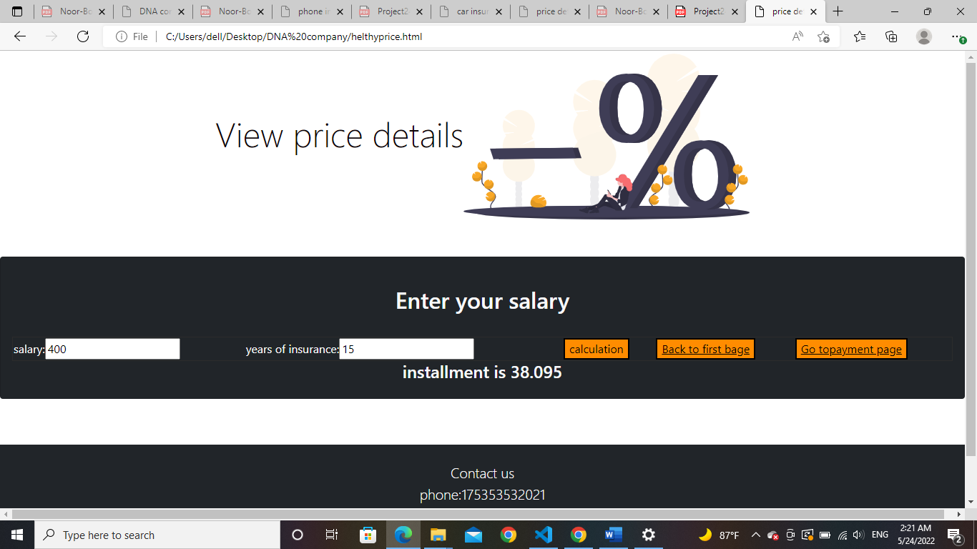

We calculated the security rate through JavaScript codes inside the html page, where we used the tag label to enter the information and then called it using JavaScript.

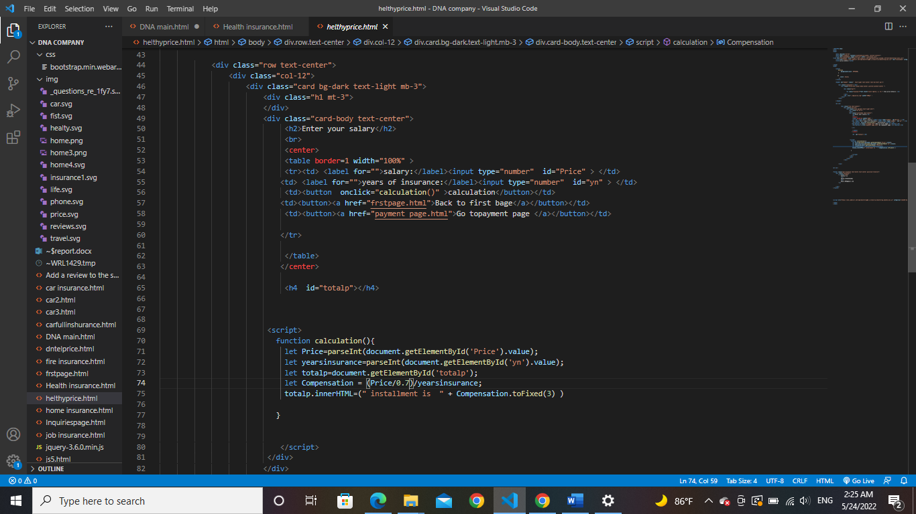

Note: The percentage varies from one type of insurance to another

If the user clicks on the back button, the link will take him back to the first page, but if he clicks on the payment button, the link will take him to the payment page





We used the same payment page that we explained earlier

There is a button to rate the service that takes the user to a page where he can write his rating for the service

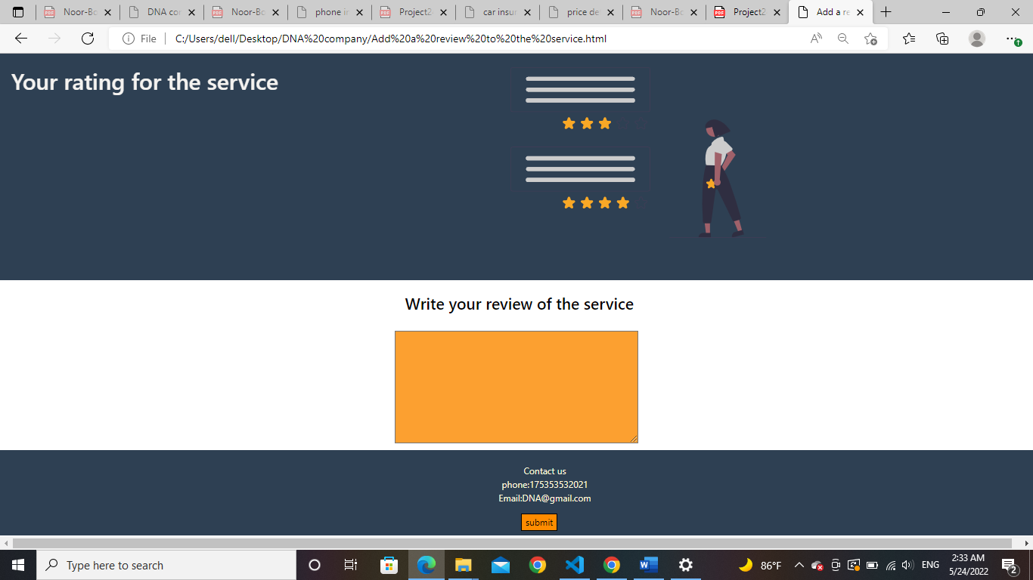

In the payment page, they used the bootstrap template used in the previous pages, and we also used the page splitting format from the bootstrap, and we added a text box in which the user can type any of what he wants at the end of the page, we added a send button

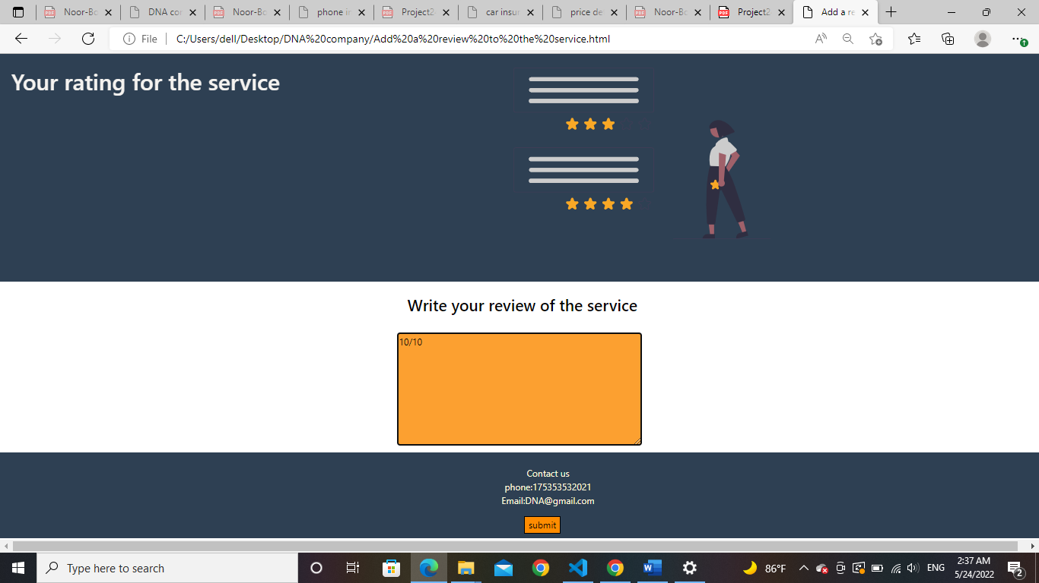

Codes used for this page

